

RLE Technologies Campaign in a Box –
Spot Detectors for Conductive Fluids

The following Campaign in a Box provides you with an easily deployed turnkey marketing program to promote the RLE’s four primary spot detectors for conductive fluids (SD-Z, SD-Z1, SD, and SD-RO1). The SD product line has recently seen a high volume of sales from a number of our partners and we feel there is a high margin sales opportunity for your company.

This promotion centers on an additional 5% discount on the SD line which we recommend you promote using the CIAB below and pass that discount along to end users as a promotional offer, and stress the sales opportunity to your sales team.

Note that the discount offer applies only to the spot detectors and not to power supplies, controllers, or other accessories.

Introduction
Thank you for your interest in promoting RLE products. The purpose of this program is to provide you with a turnkey marketing program that you can launch quickly and easily to promote RLE’s products to your customers and drive qualified pipeline for your sales team.

Below you will find information that covers a number of marketing outreach channels including:

- Online web exposure
- Email
- Social media
- Sales follow-up.
Please feel free to modify this within reason to suite your particular audience and needs as long as primary imagery and RLE trademarked materials are not modified.

Online Web Exposure
Linked below you will find a graphics file that you can use on your home page. If you have a rotating image this would be a great place to showcase it along with a message and link to the video. It also works well as a header on your leak detection page.

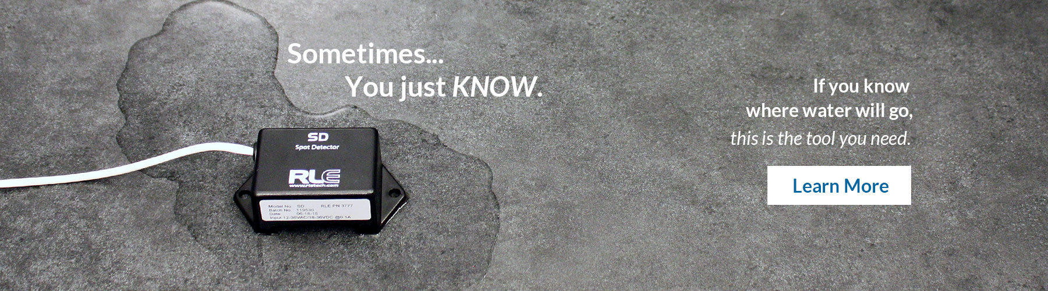
Email Copy
Subject Line: X Marks the Spot Where Your IT Equipment Gets Soaked

When you know where intrusive water will go, an inexpensive spot detector can save your assets

Fluids and your facilities’ assets simply don’t mix. The problem is that there are likely fluids running throughout your facility through fire suppression lines, plumbing lines, coolant lines and much more. And while you may never know where or when a pipe or tank is going to fail (and they do fail all the time), there are certain places where leaking fluid is likely to collect and offer you an opportunity to act BEFORE serious damage occurs.

Conductive fluid spot detectors are the perfect answer to this threat. Inexpensive and fast acting, a spot detector can be placed in a drip pan, in a floor drain, under sinks and similar places and can notify you almost instantly that there is a problem and enable you to act quickly to mitigate damage.

Special offer! 5% discount on all Spot Detector purchases placed
and filled before September 30.

Don’t let a tiny, nearly undetectable flaw in a water pipe bring your company to its knees. The risk mitigation and peace of mind alone are worth the now discounted investment. And if/when there is a leak, the ROI will simply skyrocket. Visit www.xxxxxxxxxx.com or call us at xxx-xxx-xxxx to learn more and place your order.

P.S. This is a limited time discount and despite the low price point you may need approvals. Get the process moving today!

Landing Page Copy:

Drive them to your Spot Detector e-commerce site or product page. If your site does not currently promote spot detectors we can work with you to create a discount code that your customers can enter on our site during the online quoting process that would assure the lead is routed back to you.

Social Media:
Twitter:
- RLE Spot detectors cost less than $115. The cost of water related downtime can reach six digits in less than an hour. <URL>
- Water infiltration accounts for a majority of facility downtime. RLE fluid spot detectors now on sales. <URL>
- A well placed RLE fluid spot detector can save your assets. You can have peace of mind at a discount today. <URL>
LinkedIn and Facebook:
- According to a recent survey, nearly 20% of data centers had experienced a “water event” in the last 12 months making water infiltration of a facility one of the most common causes of facility damage. RLE Fluid sensing spot detectors now on sale. <URL>

Sales talking points:
- Leak detection and spot detectors in particular are a very easy and high margin add on to many sales. This discount offer is a great opportunity to introduce the product and bolster margins and commissions.
- Surveys show that, in most types of facilities, it is not IF you will experience a significant leak event, but WHEN you will.
- Don’t fall into the trap of “we have not had an incident yet, so we probably won’t have one”. Leak detection only works if it’s installed BEFORE a leak occurs.
- It takes less than a cup of water in the wrong place to cause downtime.
- Most facilities managers have no idea just how much fluid is running through their facility and how proximate it is too sensitive equipment, products, and people.
- The cost of leak detection equipment is almost universally a tiny fraction of the cost of just one leak that causes damage.

